

BAHIRDAR INSTITUTE OF TECHNOLOGY A SOFTWARE ENGINEERING OPERATING SYSTEM INDIVIDUAL ASSIGNMENT

Name: Hana Mesfin
ID: 1601694
Section: A
Operating System: Windows Server 2022 OP

Submitted to. Wandimu Baye

Documentation for installati of window server 2022 OS

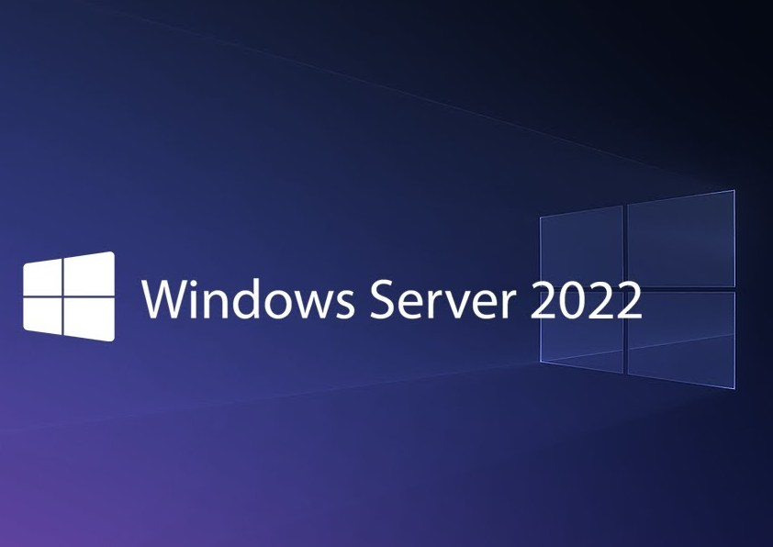

a. Introduction
i.Background
Technology has been evolving at an incredible pace, and server operating systems have become essential tools for how organizations manage their networks, files, and users. Over the years, Microsoft has steadily refined its server platforms, starting from the early days of Windows NT and gradually moving through major releases like Windows Server 2003, 2008, 2012, and so on. Each version brought in better security, more powerful tools, and greater integration with modern tech needs.
Now, we have Windows Server 2022—one of Microsoft's latest and most advanced server operating systems. It’s built with a strong focus on security, performance, and seamless cloud integration, making it a solid choice for both small businesses and large enterprises. What makes it even more accessible today is that we don’t necessarily need physical hardware to get hands-on experience with it. Thanks to virtualization tools like VMware Workstation and VirtualBox, we can run Windows Server 2022 virtually, right on our own machines.
This virtual setup is a game-changer it lets us test, explore, and learn in a safe environment, without the risk of breaking a real system. For me, since my individual OS for this project is Windows Server 2022, being able to install and configure it virtually has made the process smoother and way more flexible. It’s a great way to understand the inner workings of a server OS in a practical, hands-on way.
ii.Motivation
The decision to use Windows Server 2022 is based on several strong advantages:
•It offers long-term support all the way through 2031, which means organizations can rely on it for stability and consistent performance over time.
•It's built to work seamlessly with Microsoft Azure, making it ideal for businesses moving toward cloud and hybrid setups.
•It comes with built-in features for virtualization, containers, and Hyper-V, which makes it flexible and efficient for various enterprise needs.
•It also includes advanced security features like Secured-core and support for TLS 1.3, helping protect systems against modern threats.
b. Objectives
The main idea behind this assignment is to get some real hands-on experience with Windows Server 2022 in a virtual environment. I want to understand how it works—not just from a textbook perspective, but by actually going through the process. Here's what I’m aiming for:
•Learn how to set up and install Windows Server 2022 using virtualization software.
•Get familiar with its features and tools, especially the ones used in real IT environments.
•Practice creating user accounts and handling basic system configurations.
•Run into some problems (because that’s how you learn), and figure out how to fix them.
•Look into what kind of file systems it supports and why that matters.
•Reflect on the pros and cons of working with Windows Server in a virtual setup.
c. Requirements
i. Hardware
Processor: 64-bit CPU, preferably something like an Intel i5 or AMD Ryzen for smoother multitasking.
RAM: At least 8 GB, but 16 GB is better, especially when you’re running both the host and guest OS.
Storage: I cleared around 100 GB of space to be safe. The server itself doesn’t take up that much, but updates and snapshots add up.
Virtualization: Enabled in BIOS (VT-x or AMD-V support).
Display: Just a regular 1080p screen is enough for a comfortable experience.
ii. Software
Host OS: Windows 10 (any modern OS would’ve worked, but this is what I had).
Virtualization Software: VMware Workstation Pro (though VirtualBox is a good free alternative).
Windows Server ISO: Downloaded the official Windows Server 2022 ISO from Microsoft.
Extras:
VMware Tools (for smoother performance inside the VM)
nternet connection (for updates, troubleshooting, and tools)
Snipping Tool or screenshot software (for documentation)
How to install Windows Server 2022
-Windows Server 2022 Installation Options
Choose the install option that servers you need based on the information provided below.
Server Core – In many cases, this is the recommended installation option. Server Core is a smaller installation that includes the core components of Windows Server and supports all server roles. However, it doesn’t include a local graphical user interface (GUI). It’s mostly used for remotely managed deployments usually through PowerShell, Windows Admin Center, or other server management tools.
Server with Desktop Experience – If you want a complete installation, including a full GUI, this is your option. This option has a larger footprint than server core. It is the most preferred option by organizations.
Step-By-Step Guide to Windows Server 2022 Installation
Since VirtualBox is among the simplest and most dependable tools for generating virtual machines, I began the installation with it. This is excellent for testing and learning since it lets me run several operating systems without impacting my primary configuration. VirtualBox provided me a safe and flexible environment to work in without requiring a separate physical device as my project required me to install Windows Server 2022.
Here is precisely what I did to install VirtualBox on my computer:
Step 1: Install VirtualBox download
1 I first accessed the VirtualBox download page at https://www.virtualbox.org/wiki/Downloads.
2. I chose the Windows host edition given that I was working on a Windows computer. Then I downloaded VirtualBox's installation package.

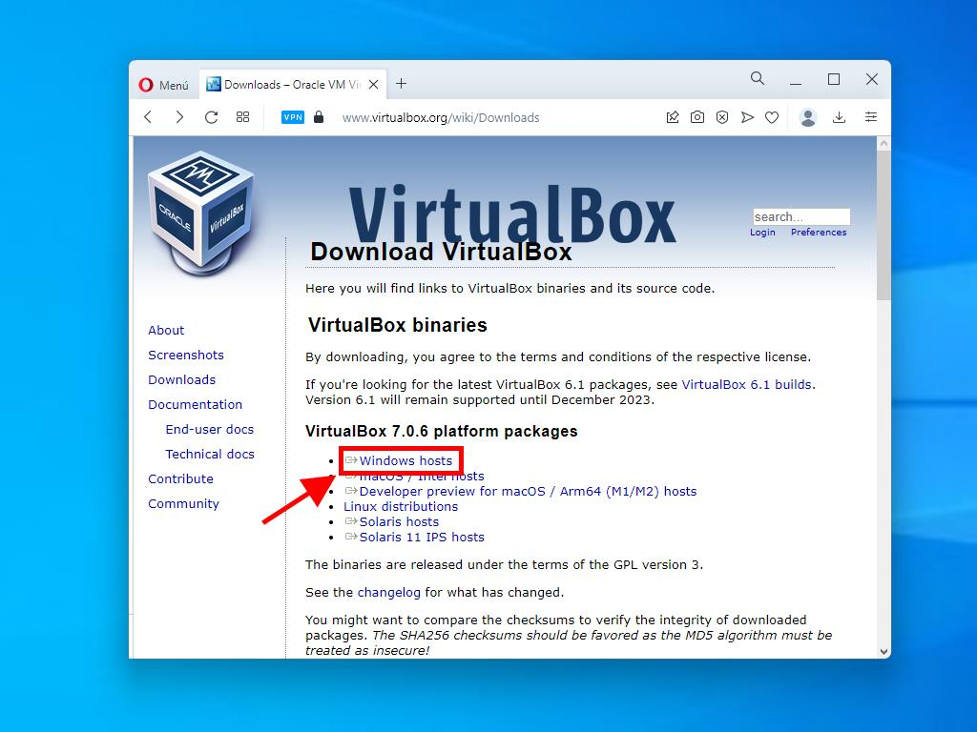

3. I opened the installer and went along with the on-screen instructions after finishing the download. The installation was simple and I was able to complete it quite well.
Step 2: Downloading Windows Server 2022
1 I started by going to the official Microsoft evaluation page for Windows Server 2022: https://www.microsoft.com/en-us/evalcenter/evaluate-windows-server-2022.

2. Once I was on the page, I clicked on the Download the ISO button under the "Get started for free" section.
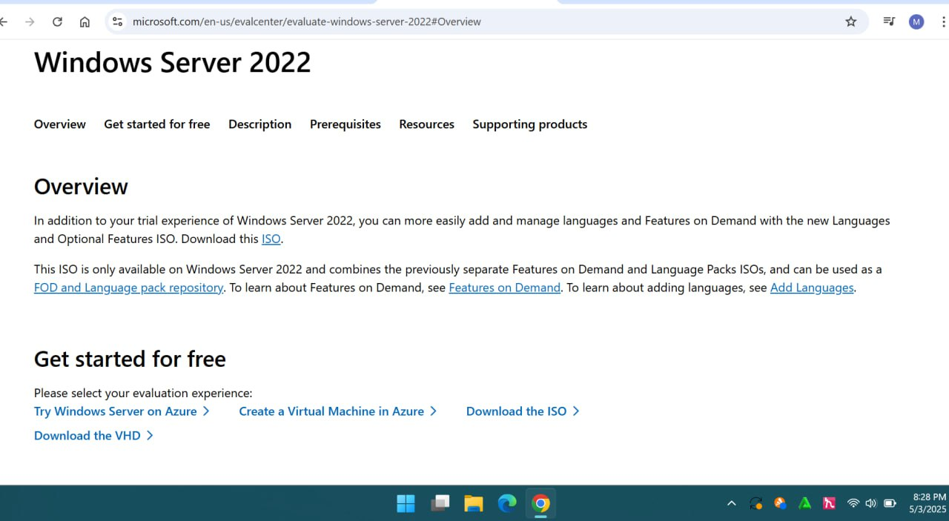

3. A registration form popped up, so I filled that out with the required information.
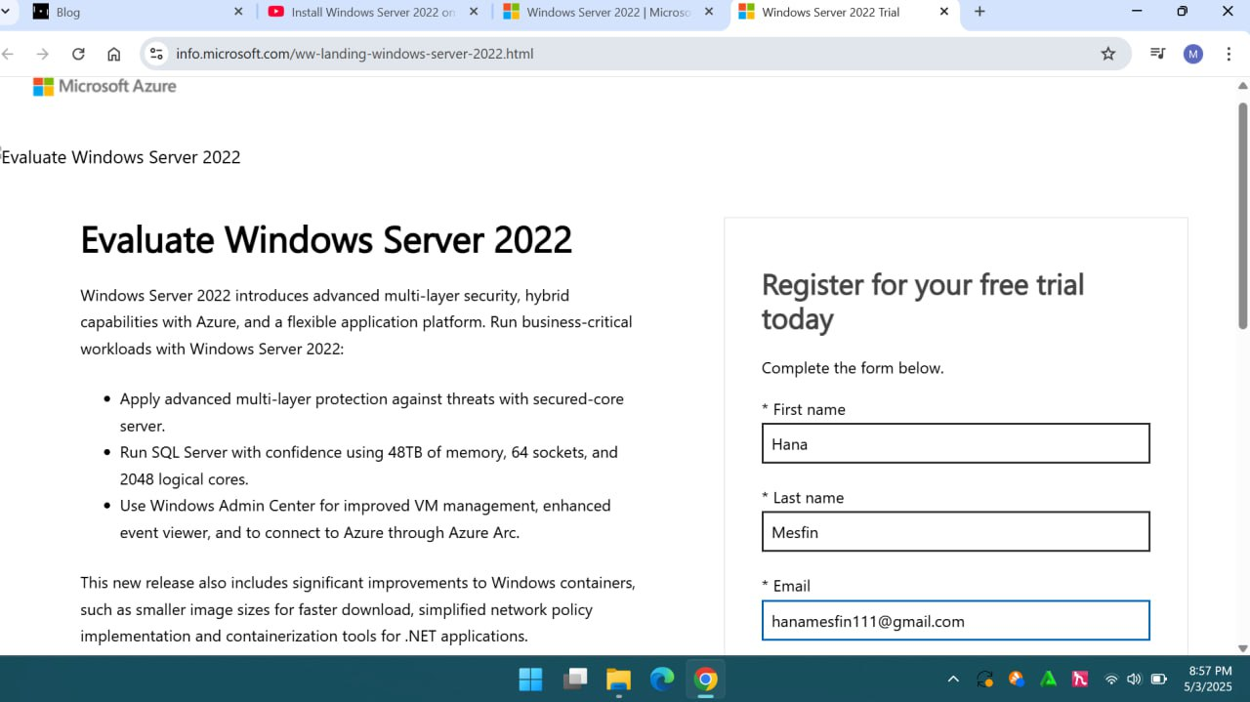

4. After completing the form, I scrolled down to the section labeled "ISO downloads" and clicked on 64-bit edition to begin downloading the file.
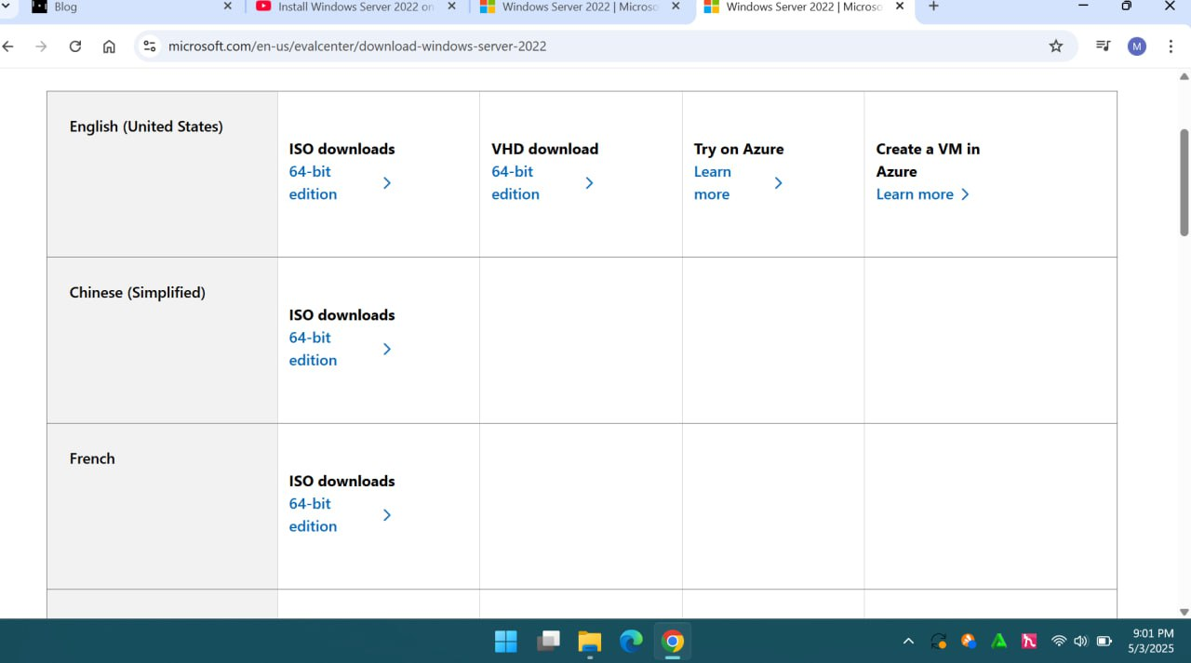

5. I made sure to save the ISO file somewhere easily accessible on my computer so I wouldn’t lose track of it later.
Step 3: Creating a New Virtual Machine in VirtualBox
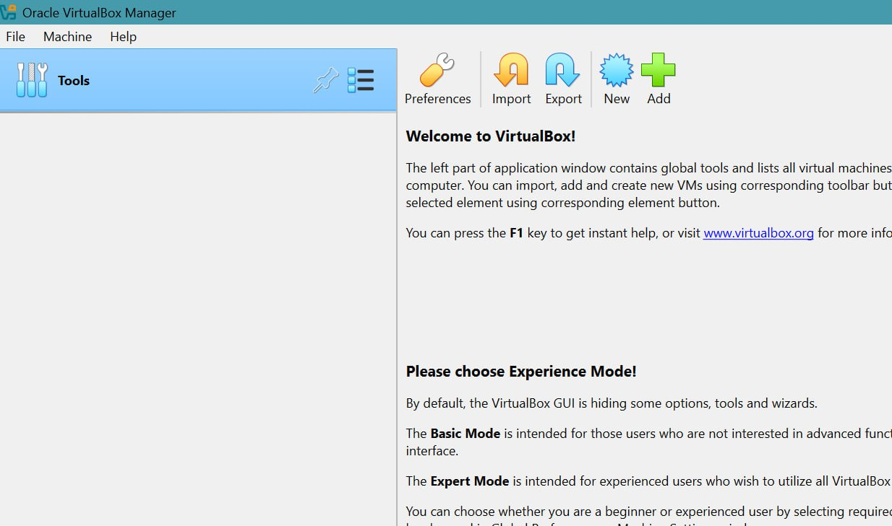
1. I opened up VirtualBox and clicked the New button to create a fresh virtual machine.

2. For the setup, I gave it a name Windows Server 2022 , and selected Windows Server 2022 (64-bit) for the version. I also made sure to check Skip unattended installation to avoid preconfigured settings.

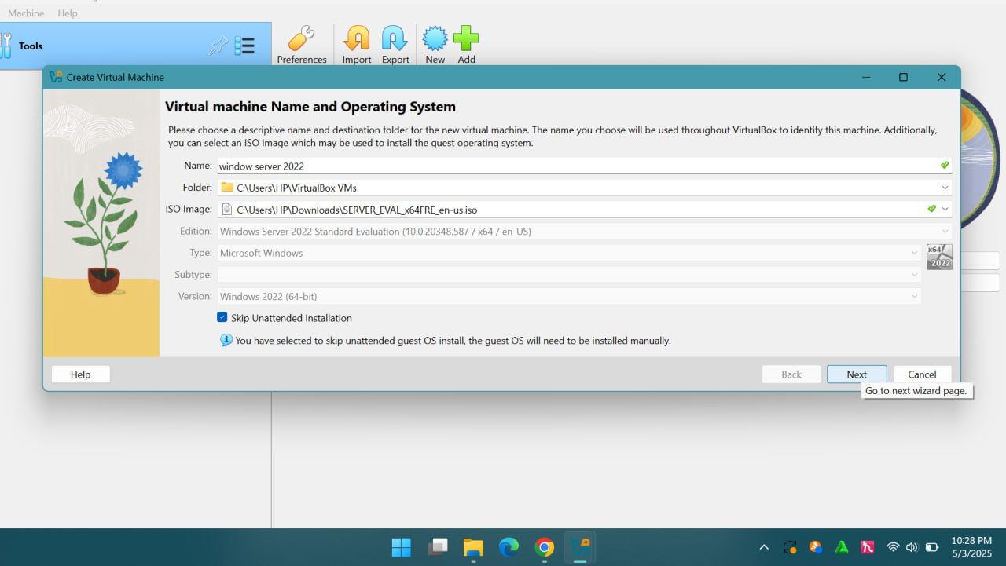

3. After that, I set the memory size to 4 GB (4096 MB) and assigned 2 CPUs, just to give it decent performance.
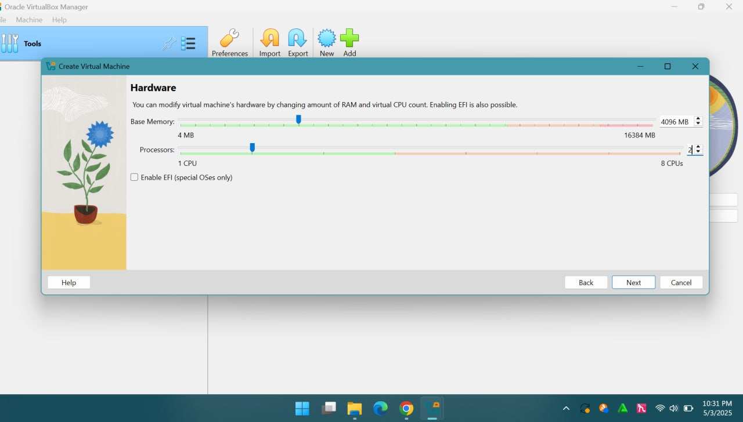

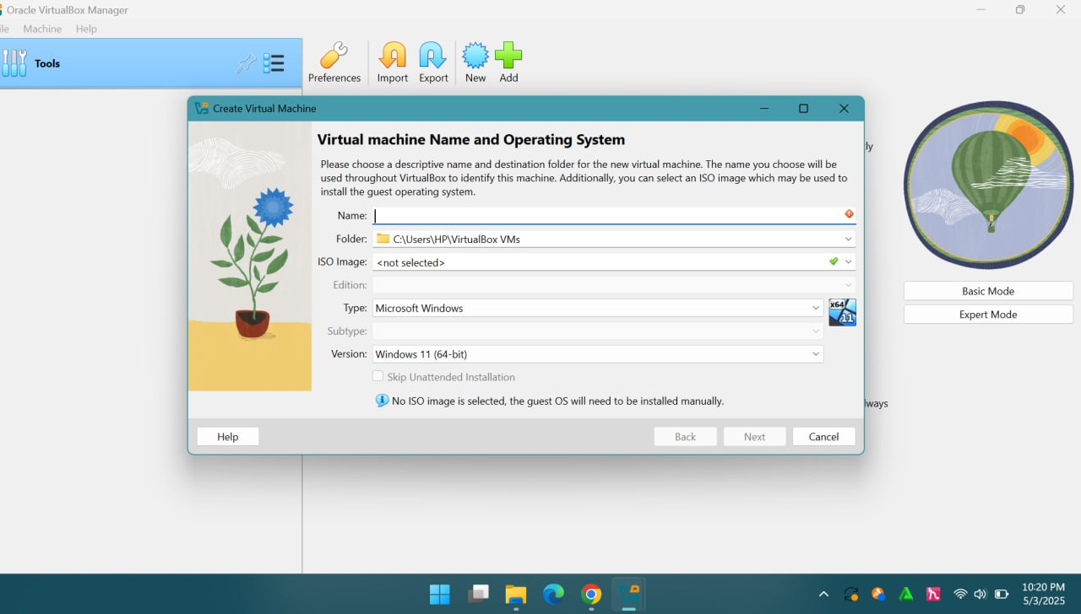
4. I chose the option to Create a virtual hard disk now and set the storage size to 50 GB, which is enough for a basic install.
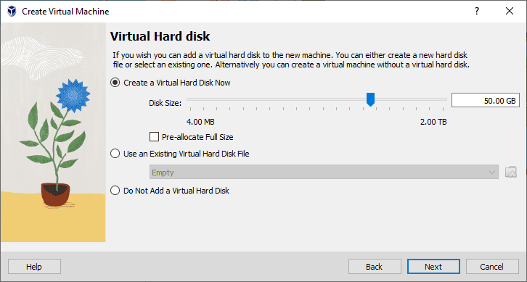

5. Once all that was done, I clicked Finish to complete the virtual machine setup.
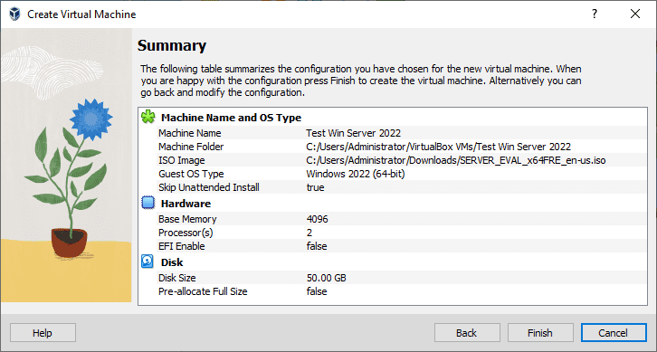

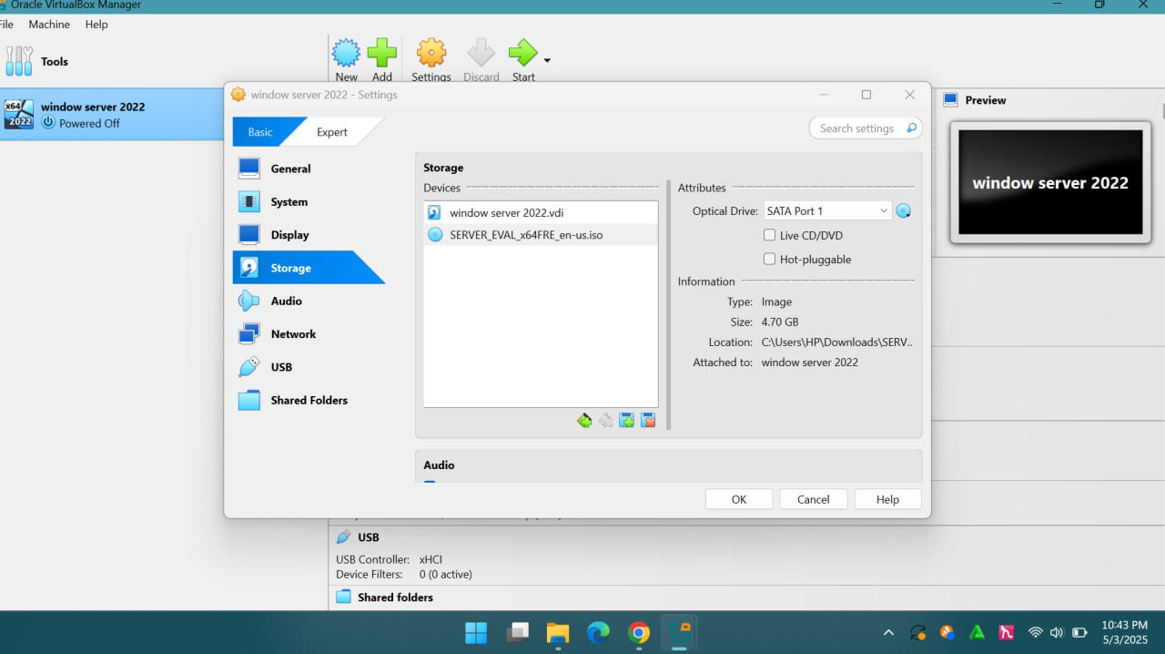

Step 4: Installing Windows Server 2022
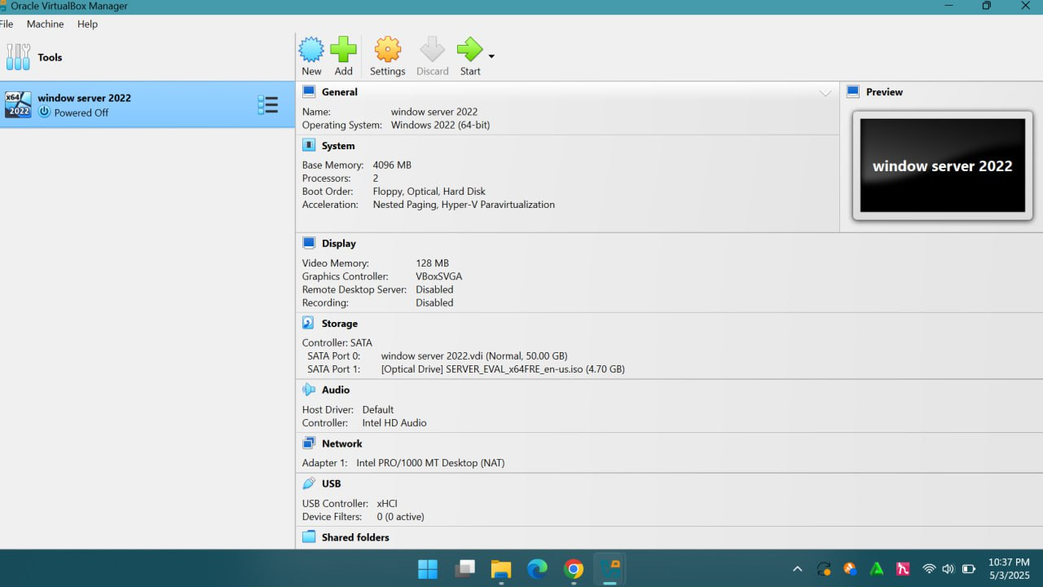
1. With the virtual machine selected in VirtualBox, I hit the Start button to launch it.

2. It took a moment, but eventually, the setup screen appeared and started loading files.
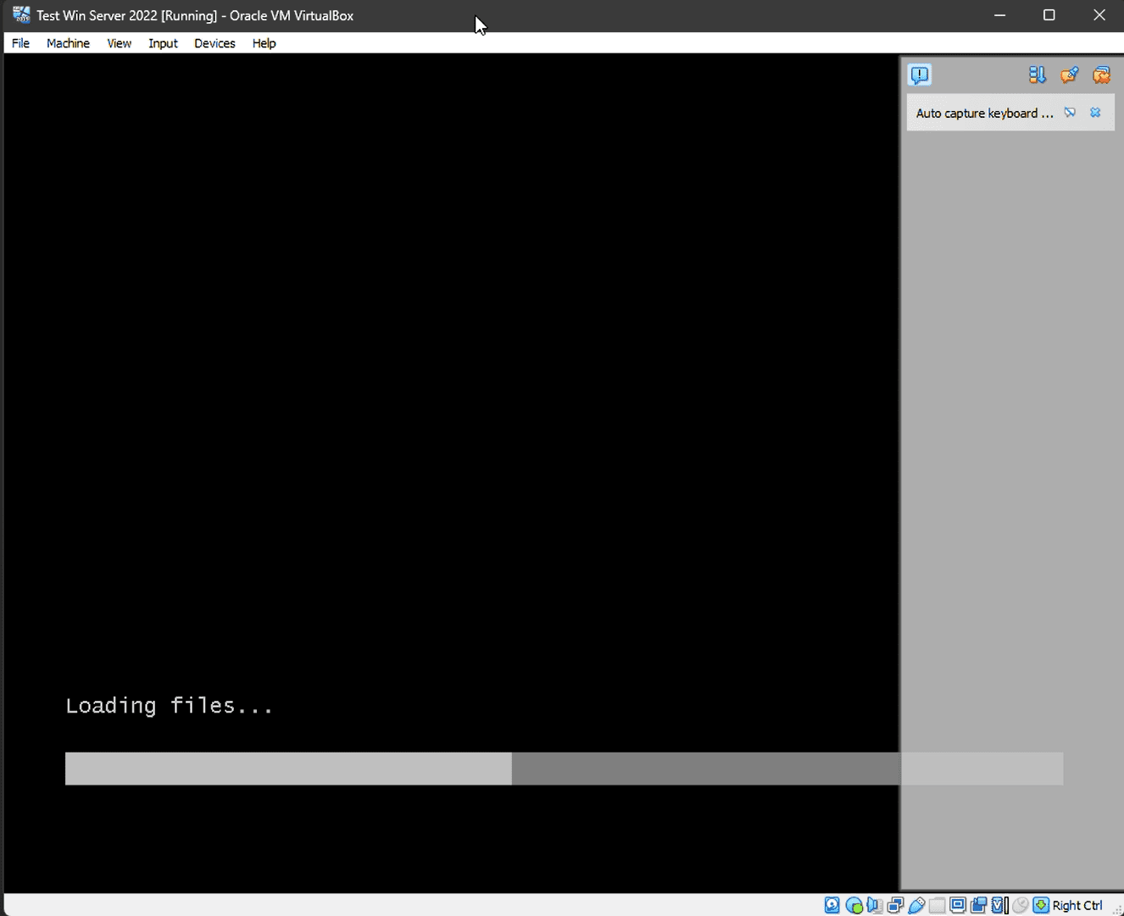

3. When prompted, I chose my preferred language and region settings.

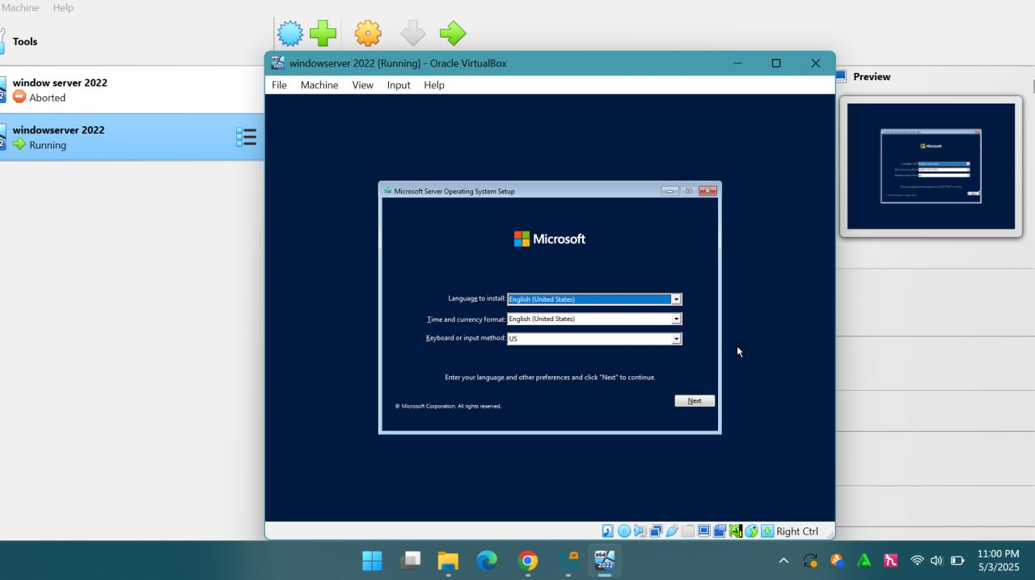

4.i press install then I selected the Windows Server 2022 Standard Evaluation (Desktop Experience) version, since I wanted the full desktop interface.

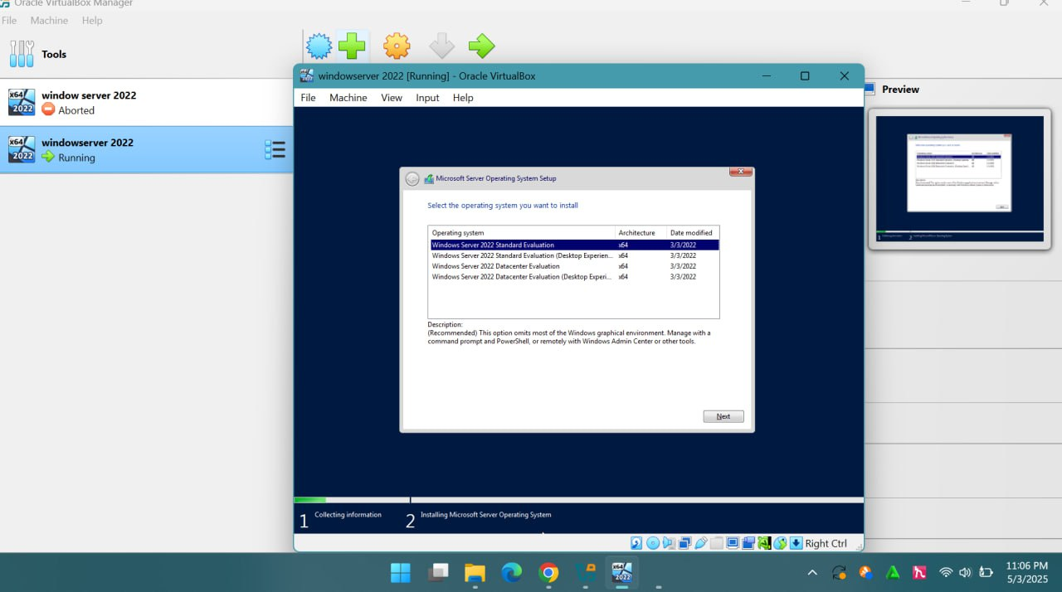

5. I accepted the license agreement as part of the next step.
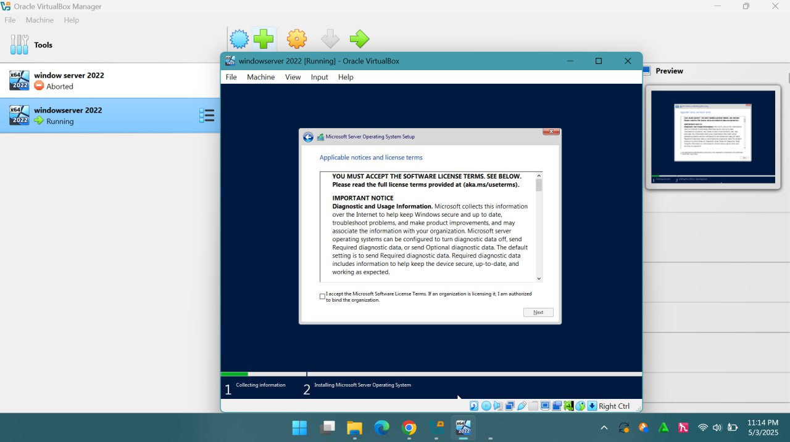

6. For the installation type, I went with Custom: Install Microsoft Server Operating System only (advanced).
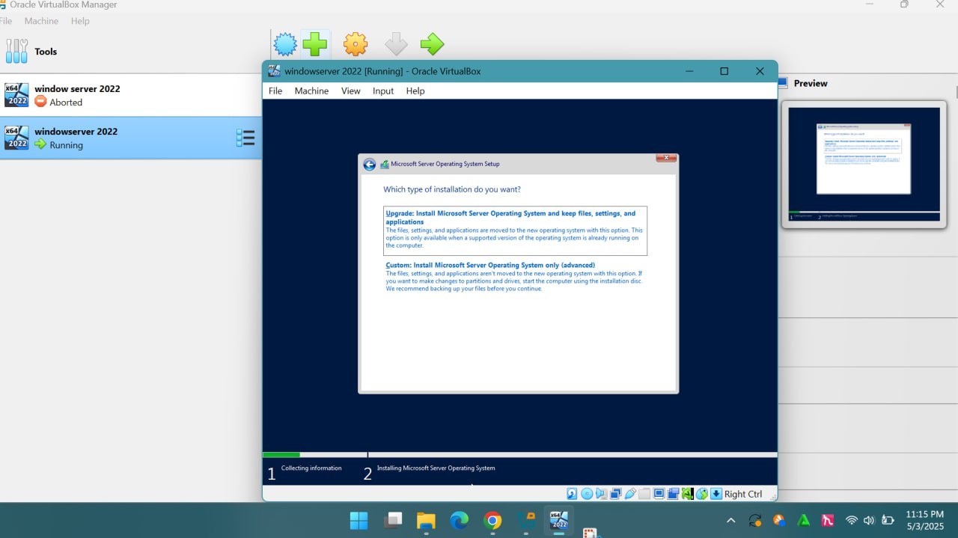
7. It then showed me the virtual disk I created earlier—I selected it and clicked Next.
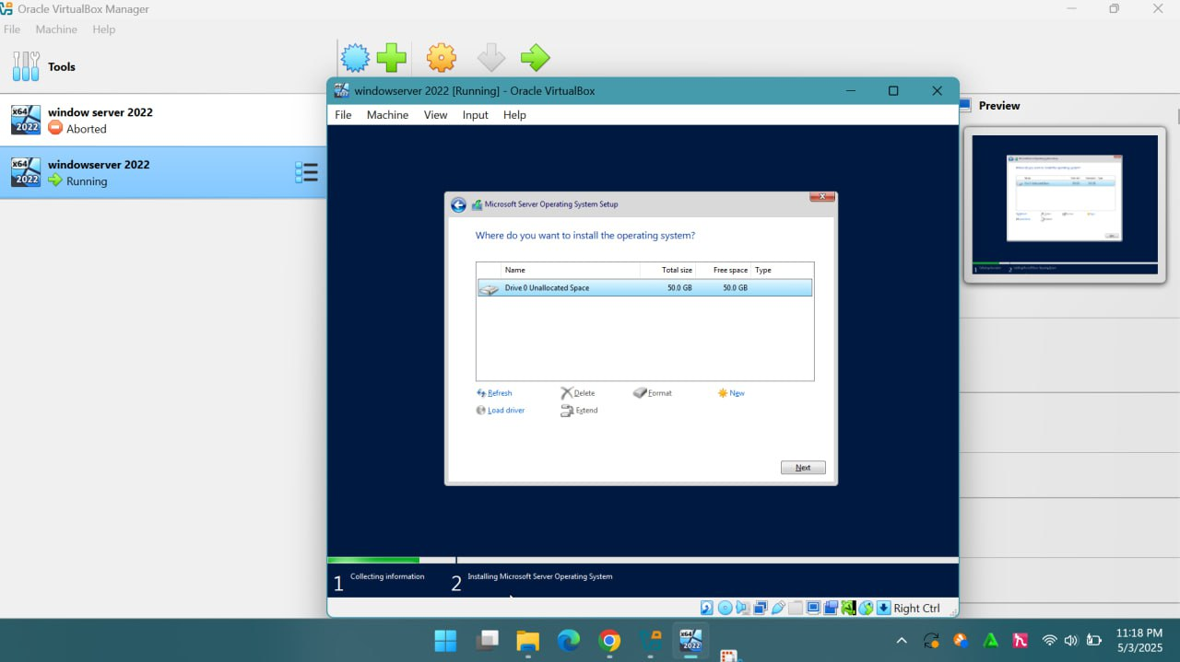

8. The installation process began and took a few minutes to complete.
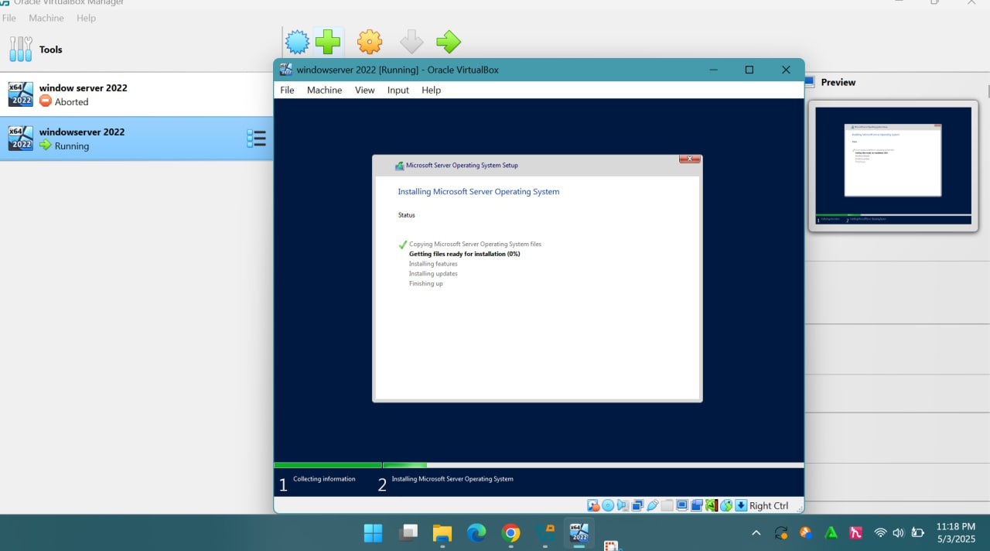

9. When it finished, the system automatically restarted. I made sure not to press any key during the reboot, so the setup wouldn’t start over from scratch.

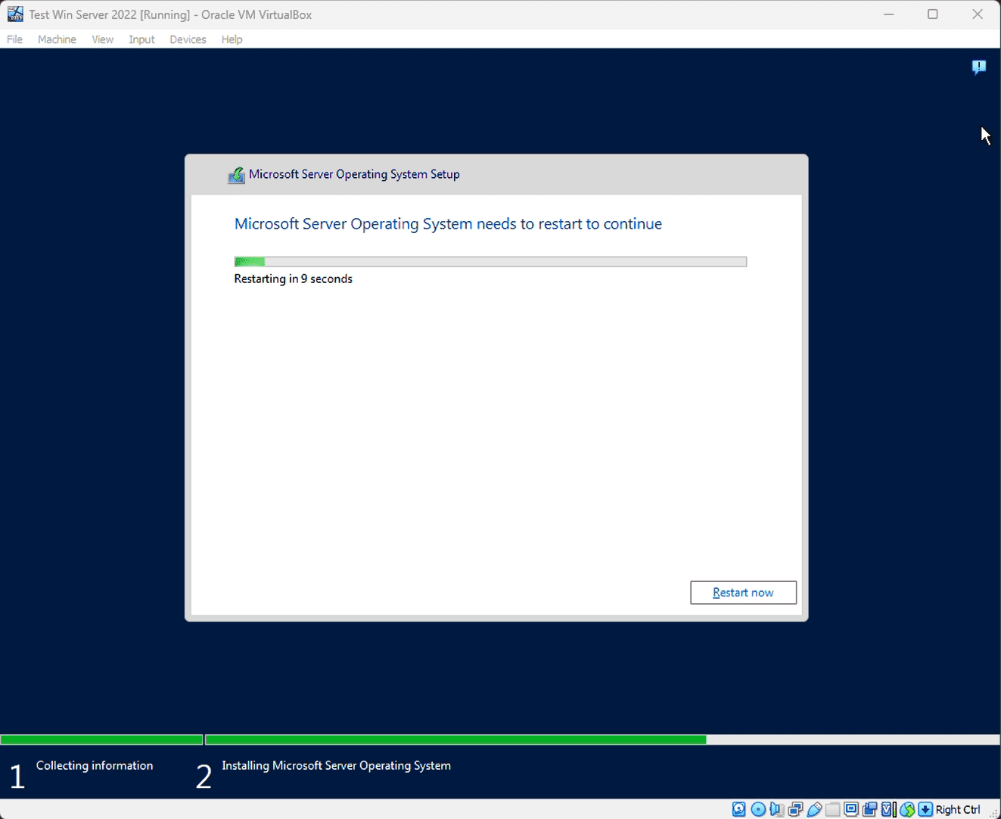

10. After rebooting, I was asked to create a password for the Administrator account, which I set and saved.
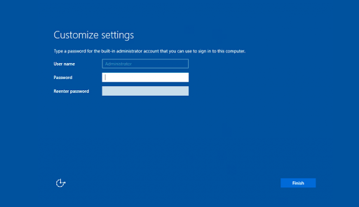

At the logon screen I send the Ctrl+Alt+Del input to the VM. This can also be done with the right Ctrl+Del keys.
11. At this point, everything was done, and I had a fully working Windows Server 2022 trial running smoothly in VirtualBox.
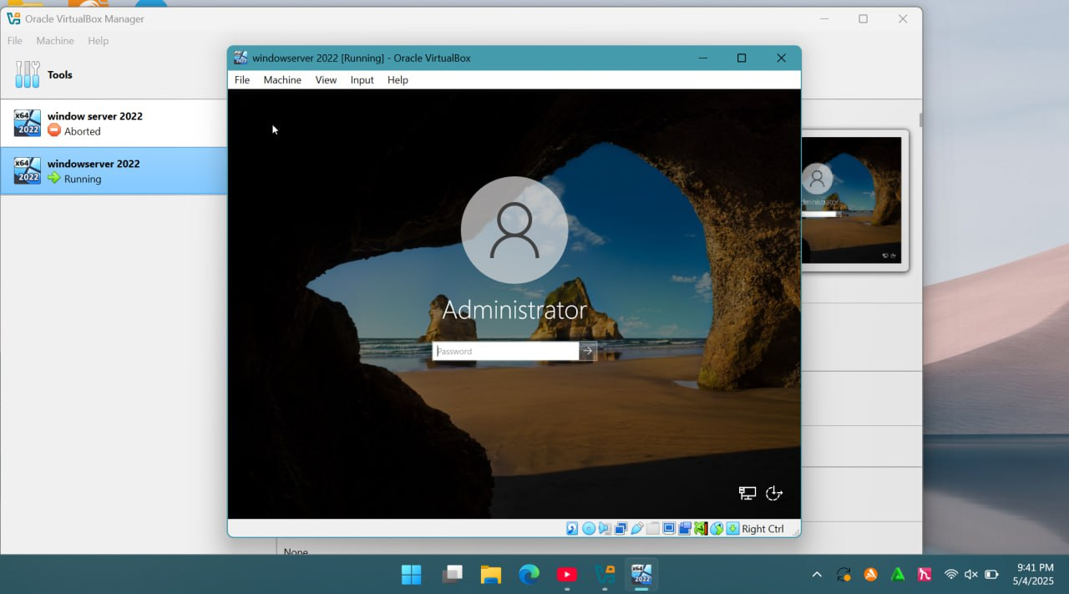

•window server 2022

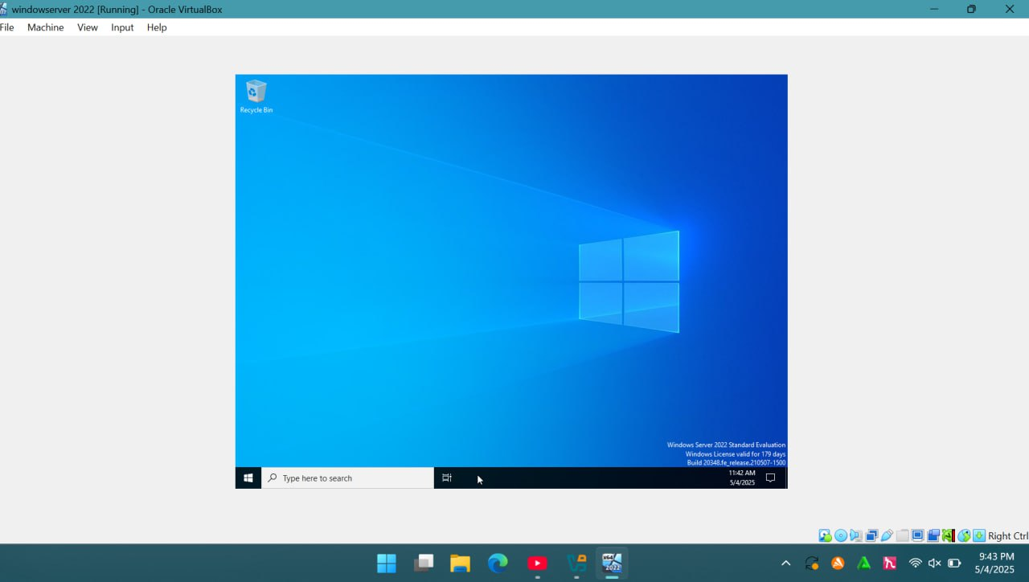

Step 4. Configuration
Now that the installation was complete, it was time to configure the server. One of the first and most important steps was setting up the network—specifically the IP address and gateway. This part ensures the server can connect to the rest of the network and be accessed remotely, as well as reach online services when needed.
Step 4.1 Network configuration on Windows Server 2022 Server Core
Since Server Core doesn’t have a GUI, everything is done from the command line. Here's how I set it up:
1. First, I opened the Command Prompt and typed in:
SConfig

This command launched a helpful Server Configuration menu.
2. From the list of options that appeared, I selected Option 8 - Network Settings. That brought me to the network configuration interface, where I could make changes to either wired or wireless connections.
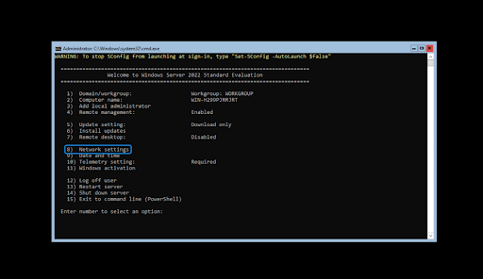

Network settings interface
3. The next step was to pick the specific network interface I wanted to configure. In my case, the server only had one network adapter listed, so I selected 1. If you have more
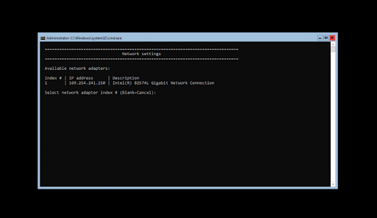
than one adapter, just choose the correct one for your setup.

4. After selecting the adapter, I was able to start customizing the IP settings. I set a static IP address, subnet mask, gateway, and DNS. The changes were applied automatically, and the whole process took just a few minutes.
Step 4.2 Network configuration on Windows Server 2022 Desktop Experience
If you’re working with the Desktop Experience version of Windows Server 2022, network configuration is much more visual and user-friendly. Here’s how I handled it:
1. I clicked on the Search icon (the little magnifying glass on the taskbar), or just pressed Windows + S to bring it up quickly.
2. Then I typed Control Panel and opened the first result. Once it loaded, I navigated to: Network and Internet > Network Connections
3. I found the active network connection (there was only one on my server, but you might see more), right-clicked it, and selected Properties from the menu.
4. From there, I could adjust the network settings just like on a regular Windows 10 PC—assigning a static IP, configuring DNS servers, and so on. Super straightforward.
How to install Server 2022 Updates
Click Start > Settings
Select Update and Security.
Click Check for Updates.
Now you should see the latest updates available for your Server 2022.
Click Install Now to begin the installation of updates
e. Issues (Problems I Faced)
While installing Windows Server 2022, things mostly went okay—but of course, I hit a few along the way. Some were small and expected, but others had me googling and testing for a bit. Here’s what went wrong:
1. Slow installation stuck at a certain percentage
At one point, the installation just seemed to freeze stuck at around 62% for what felt like forever.
2. Network adapter not working after install
After everything was installed, the server couldn’t connect to the internet. No networks were showing, and the adapter wasn’t recognized.
f. Solutions
1.I waited for a bit, but then I restarted the process and this time, I disconnected everything unnecessary—extra USB drives, Wi-Fi dongle, even an external keyboard. Turns out, sometimes external devices can slow down or confuse the installer. After that, the installation went through smoothly.
2.This one was pretty straightforward. Windows Server doesn’t always include drivers for all network cards by default. I used another PC to download the latest network driver from the manufacturer’s site, put it on a USB stick, installed it manually, and boomnetwork came back online.
g. Filesystem Support
i.What Is File System Support?
When we say "file system support" in an operating system, we're really talking about the operating system's ability to recognize, understand, and manage different ways of organizing data on a storage device—like hard drives, SSDs, USBs, or SD cards.
An operating system doesn’t just store data randomly. It needs a structured system that defines how files are named, saved, retrieved, and secured. That structure is called the file system—and “file system support” means the OS is built to work with one or more of those systems.
To put it simply:
If you plug in a USB drive formatted with a file system like FAT32, and your computer can open the files, that's because your operating system supports FAT32. The OS knows how to interpret the structure of that file system, read it properly, and let you work with the files stored there.
ii.What does a file system do?
Typically, file systems are responsible for these operations:
•Data storage and management: File systems help organize files into directories and sub-directories and manage space on the storage device.
•Naming files: File system provides a mechanism for naming files and directories. Some file systems follow naming rules that include allowable characters and file name lengths.
•File access: File systems determine how files are accessed i.e., read, write, and execute permissions.
•Retrieve data: Tracking where files are stored on the disk is also done by file systems. This ensures retrieval is quick even if the data is spread across physical locations on the disk.
•File security: Modern file systems provide mechanisms to protect files from unauthorized personnel through permission settings.
•Metadata: Each file has associated data with metadata. This metadata contains information about size, type, creation date, modification date, and permissions. File system maintains metadata and makes its users manage and sort files.
iii.Types of file system
FAT, FAT16, and FAT32
The File Allocation Table, better known as FAT, is one of the earliest file systems to gain widespread use. Originally built for MS-DOS, it's still commonly found today on many removable drives like USB flash sticks and memory cards. Over time, two main versions came out—FAT16 in 1987 with DOS 3.31, and FAT32 in 1996 as part of Windows 95 OSR2.

Pros:
•Straightforward Design: Its simplicity makes FAT easy to set up and use, especially on devices with limited hardware resources or where wide compatibility is needed.
•Easy Data Recovery: Because of its simple structure, recovering lost files or repairing data on a FAT system tends to be easier compared to more complex file systems.
°Cross-Platform Compatibility: FAT can be read and written to on Windows, macOS, and most Linux systems without any special drivers or tools.

Cons:
•Fragmentation Issues: As files are created, deleted, or changed, data gets scattered, slowing things down. It often needs defragmentation to stay fast.
•Lack of Modern Features: FAT32 doesn’t support things like user permissions, encryption, journaling, or compression—features that are standard in newer systems.
•Naming Limitations: FAT16 only allows filenames in the 8.3 format (eight characters plus a three-character extension), and volume names are restricted to 11 alphanumeric characters.

exFAT (Extended FAT)
exFAT, introduced by Microsoft in 2006 with Windows CE 6.0, was designed as a more capable version of FAT32. It’s often used on external drives like SSDs and SD cards due to its support for large files and good compatibility across platforms.
Pros:
•Handles Large Files Easily: Unlike FAT32, exFAT can store files larger than 4 GB, making it a better fit for high-resolution video, disk images, and large software packages.
•Efficient Space Use: It reduces wasted space by supporting smaller cluster sizes, which is especially helpful when storing lots of small files.
•Cross-Platform Use: Native read/write support is available on Windows and macOS, making it ideal for external storage used across different devices.
Cons:
•Lacks Advanced Features: Like FAT32, exFAT still doesn’t offer journaling, file permissions, or built-in encryption.
•Still Prone to Fragmentation: File fragmentation can occur over time, especially with frequent file changes, impacting performance.

NTFS (New Technology File System)
NTFS is Microsoft's modern file system, first introduced in 1993 with Windows NT 3.1. Since then, it's become the standard on all Windows versions. It’s packed with advanced features like file permissions, compression, encryption, and journaling.
Pros:
•Robust Security: NTFS allows fine-grained control over who can access files and folders, using permissions tied to users and groups.
•SSD Optimization: NTFS supports TRIM for SSDs, which helps improve drive performance and lifespan by cleaning up deleted data blocks automatically.
Cons:
•Time-Consuming Repairs: If something goes wrong, fixing NTFS errors can take a while and may require special tools or utilities.
•Fragmentation: Despite its modern design, NTFS can still become fragmented over time, which might slow down performance, especially on older drives.
APFS (Apple File System)
Apple introduced APFS in 2017 with macOS 10.13 as a replacement for HFS+. It’s optimized for flash and SSD storage and is now the default file system on Macs, iPhones, iPads, and other Apple products.
Pros:
•Great Performance: APFS uses smart techniques like copy-on-write, metadata optimization, and space sharing, which all contribute to faster read/write operations.
•Built-In Security: It has native support for encryption and includes checksums to guard against data corruption, giving users better protection for their files.
Cons:
•Limited Trim Efficiency: Although it supports TRIM on SSDs, it may not perform as efficiently as other file systems in managing unused space.
○Compatibility Issues: Older software and utilities may not fully support APFS. Plus, Windows can’t read or write to APFS-formatted drives without third-party help.

HFS and HFS+
The Hierarchical File System (HFS) was Apple's original file system, launched back in 1986 with the Mac Plus. It was later upgraded to HFS+ in 1998, which added support for larger files and volumes. Apple officially replaced HFS+ with APFS starting in 2017.
Pros:
•Easy to Understand: Its structure is relatively simple, which made it easier to develop for and troubleshoot back in the day.
•Metadata Handling: HFS supported metadata and resource forks, which let it store additional information about files, including types and icons.
Cons:
•Outdated Features: HFS and HFS+ lack modern features like encryption, journaling (on original HFS), and compression.
•File Transfer Issues: Files copied out of HFS systems may lose essential information if they weren’t zipped or archived beforehand, especially files without extensions.
•Size Limits: HFS struggles with very large files or partitions—it maxes out at 2 GB for files and 2 TB for partitions.

Ext4 (Fourth Extended File System)
Ext4 is the default file system on most Linux distributions. Introduced in 2003, it’s the successor to Ext3 and brings improvements in speed, reliability, and capacity.
Pros:
•Journaling for Safety: It logs changes before writing them to disk, which helps recover data after crashes or power loss and keeps the file system consistent.
•Handles Big Data: Ext4 can support very large files and partitions, making it scalable for modern storage needs.
Cons:
•Fragmentation Still Happens: Although better optimized than older file systems, Ext4 can still suffer from fragmentation over time.
•Scalability Limits: While it’s suitable for most personal and even enterprise use, Ext4 isn’t ideal for ultra-large-scale systems, such as data centers with petabytes of data.
iV.File System Support in Windows Server 2022
1. NTFS (New Technology File System)
Why it’s used: NTFS is the most common filesystem for Windows-based systems, including servers. It’s reliable, supports large files, and has built-in security features like file permissions and encryption (EFS). For most installations of Windows Server 2022, NTFS is the default choice.
Key features:
•Security: Supports file and folder permissions, encryption, and access auditing.
•Scalability: Can handle very large files and partitions (up to 256 TB).
•Reliability: Includes features like journaling, which helps recover data if the system crashes.
Use case: NTFS is the go-to choice for most server configurations where compatibility, security, and data integrity are priorities. It’s especially useful for local storage and file-sharing setups.
2. exFAT (Extended File Allocation Table)
Why it’s used: exFAT is typically used for removable drives (like USB sticks and external hard drives) due to its ability to work across different platforms (Windows, macOS, Linux). While not as common in server environments, you might encounter it when managing data between multiple OS platforms.
Key features:
•Cross-platform compatibility: Works with Windows, macOS, and some Linux distros.
Large file support: Supports files larger than 4 GB, unlike FAT32.
•Simple structure: Less overhead compared to NTFS, making it faster for smaller tasks.
Use case: exFAT is great for when you need to share files between systems or store large files on external drives. However, it’s not suitable for server use due to a lack of advanced features like security and journaling.
3. ReFS (Resilient File System)
Why it’s used: ReFS is a newer filesystem designed for high-availability and data integrity, making it ideal for virtualized environments and data-heavy server applications. It’s especially important when working with large volumes of data and where redundancy and fault tolerance are critical.
Key features:
•Data integrity: Protects against data corruption and automatically repairs data issues.
•Scalability: Can handle extremely large volumes (up to 35 PB).
Virtualization support: Optimized for use with virtual machines and large-scale data management.
Use case: ReFS is great for storage volumes that require high reliability and large data sets, such as file servers, databases, and virtualized environments. However, it’s important to note that it’s not backward-compatible with older systems, and it’s not as commonly used as NTFS in all server setups
For most Windows Server 2022 setups, NTFS is the best choice because it’s fully supported, reliable, and secure. Use exFAT if you need to share files between different OSes or work with external media. Opt for ReFS when you’re setting up large-scale storage solutions or want maximum data protection and performance, especially in virtualized environments.
g.Advantages of Windows Server 2022
1. Better performance where it counts:
One of the things you’ll notice right away is how smooth Windows Server 2022 runs. With the updated kernel and various system optimizations, it handles tasks more efficiently, especially under heavier loads. That means faster response times and better use of your hardware.
2. Stronger cloud integration:
This version works really well with Microsoft Azure, which is a huge plus if you’re running a hybrid setup. It gives businesses the flexibility to operate both on-premises and in the cloud without hitting compatibility snags.
3. Enhanced security features:
Security is clearly a big focus here. Features like Secure Core Server and built-in support for multi-factor authentication help keep systems protected. Given how fast threats are evolving, these updates are essential.
4. Simplified management tools:
Windows Admin Center is a game-changer. It makes managing everything from one dashboard feel intuitive and saves you from jumping between tools. If you’ve ever had to monitor multiple servers, you’ll definitely appreciate the convenience.
5. Better support for containers:
Windows Server 2022 comes with improved container support. If you’re working with modern, container-based applications or microservices, these updates make deploying and running them a lot smoother.
6. Smarter data storage options:
Microsoft’s added new tools to help with data migration, plus made general improvements to how data is stored and accessed. This helps IT teams manage files more easily and with greater flexibility.

-Disadvantages of Windows Server 2022
1. Higher system requirements:
With all these improvements, it’s not surprising that the new system demands more from your hardware. If you're running on older machines, an upgrade might be necessary just to keep everything running smoothly.
2. Tricky upgrade process:
Moving to a new server OS is never exactly easy—especially in environments with lots of moving parts. Planning, testing, and downtime all come into play.
3. Compatibility issues with some apps:
Not every third-party application plays nice with new versions right away. It might take a while before updates catch up, so be prepared for some hiccups during the transition.
4. Legacy hardware support:
If your infrastructure includes older equipment, you might run into compatibility roadblocks. Some features just won’t work unless the hardware is fairly recent.
5. Training curve:
New tools and interface changes mean your team might need a bit of a learning curve. While the updates are great, staff retraining can take time and resources.
i. Conclusion
All in all, working with Windows Server 2022 in a virtual environment was a pretty solid learning experience. I got a better understanding of how server operating systems actually work—way beyond just clicking around on regular Windows. Setting it up in VirtualBox gave me the freedom to try things out, mess up, and fix stuff without risking my main system.
I was also able to see how important things like user account control, networking, and file system choices really are. Before this, I mostly thought of servers as just "big computers," but there’s way more going on behind the scenes—especially with stuff like domain management, security settings, and virtualization features.
Even though I ran into a couple issues, figuring out how to fix them using PowerShell and Command Prompt made the whole thing feel more hands-on and real. It wasn’t just theory—I actually had to troubleshoot, tweak things, and learn by doing, which helped the concepts stick a lot better. this assignment wasn’t just about installing an OS—it gave me a real taste of what it’s like to work with server infrastructure
j. Future Outlook / Recommendations
Looking ahead, I think Windows Server 2022 is going to stick around for a while, especially in businesses that rely on Microsoft ecosystems. It's built for modern infrastructure, with more cloud-ready features than older versions, and it plays nicely with Azure and other virtualization tools. So for anyone getting into networking, system admin, or cloud tech, learning it now is definitely worth the time.
1. Learn PowerShell Early
It’s honestly a game-changer once you get the hang of it. A lot of stuff in Windows Server can be done faster with PowerShell than through the GUI. I wish I started using it earlier in this project—it would've saved me some clicks.
2. Use Snapshots Often
If you're working in a virtual machine, snapshots are your best friend. I made the mistake of skipping this and had to redo part of the install after messing up a setting. Lesson learned.
3. Try Combining with Other Services
Once you're comfortable with the basics, try adding stuff like Active Directory, DHCP, or even experimenting with remote access. That’s where the real-world usefulness kicks in.
4. Keep an Eye on New Versions
Microsoft updates their server OS every few years, and with how fast cloud computing is moving, it’s smart to stay current. Even if you start with 2022, keeping an eye on future releases will help you stay relevant in the field.
2.Briefly explain the what,why and how virtualizationin modern operating system.
What is Virtualization?
Virtualization is a technology that allows you to run multiple virtual systems on a single physical machine. It essentially lets you create "virtual" versions of physical resources, like servers, storage, and networks. These virtual systems behave just like separate machines, but theyshare the physical resources of the host machine. Many businesses use virtualization to get more value from their hardware and reduce costs. It also powers cloud computing, helping companies manage their infrastructure more effectively.
To understand how virtualization works, it’s helpful to know a few basics first. Essentially, virtualization allows a computer to divide up its resources—like memory, CPU, and storage—and run multiple environments, or virtual machines (VMs), each operating as if it were a separate machine. This way, an organization can run different operating systems on the same server without needing to reboot, which is a huge advantage for flexibility and efficiency.
Why is Virtualization Important?
•Maximizes Hardware Use: Instead of running several physical servers with low utilization, virtualization allows one machine to host several VMs, saving both space and power.
•Cost Savings: Fewer physical machines mean lower hardware, electricity, and maintenance costs.
•Flexibility: You can run various operating systems on one machine, and VMs can be easily moved, cloned, or reconfigured as needed.
•Remote Accessibility: Virtual systems can be accessed remotely, so physical location isn't an issue.
•Quick Setup: New servers can be created almost instantly from templates, making development and testing faster.
•Scalable and Cloud-Ready: Virtualization is the backbone of cloud services, allowing companies to easily scale their infrastructure on-demand.

How Does Virtualization Work?
Virtualization works through specialized software called a hypervisor, which creates and manages virtual machines on a physical computer. Think of the hypervisor as a middleman: it allocates resources like CPU, memory, and storage from the host machine and divides them among several VMs.
Virtual machines and hypervisors are two important concepts in virtualization.
Virtual machineical computer with a separate operating system and computing resources. The physical computer is called the host machine and virtual machines are guest machines. Multiple virtual machines can run on a single physical machine. Virtual machines are abstracted from the computer hardware by a hypervisor.
Hypervisors
Hypervisors Sometimes called a virtual machine monitor (VMM), a hypervisor is software that separates a system’s physical resources and divides those resources so that virtual environments can use them as needed. A hypervisor takes physical resources (such as CPU, memory, and storage) from the hardware and allocates them to multiple VMs at once, enabling the creation of new VMs and the management of existing ones. Hypervisors can sit on top of an operating system (like on a laptop) or be installed directly onto hardware (like a server). The physical hardware, when used as a hypervisor, is called the host, while the many VMs that use its resources are guests. When the virtual environment is running and a user or program issues an instruction that requires additional resources from the physical environment, the hypervisor relays the request to the physical system and stores the changes in a cache—which all happens at close to native speed.
There are two main types of hypervisors, and each serves a different purpose:
Type 1 Hypervisors: These run directly on the physical hardware, without an operating system. They're more efficient because they interact directly with the system's resources. They're often used in server environments for their reliability and performance.
Type 2 Hypervisors: These are installed on top of an existing operating system (like Windows or Linux). Type 2 hypervisors are commonly used when you want to run multiple operating systems on a single machine—great for testing or development.
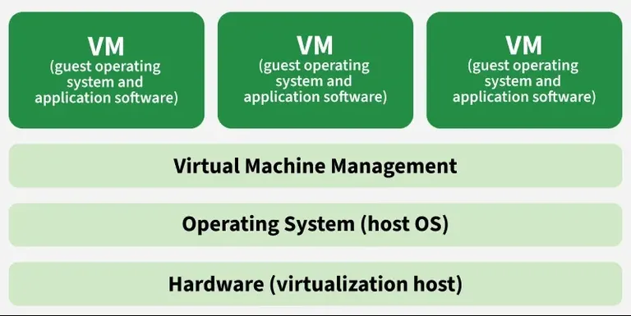
With both types of hypervisors, the virtual machines that run on them behave just like physical machines, but they're entirely separate, isolated from each other. The hypervisor makes sure each VM has the right amount of resources and keeps them from interfering with each other.

